Lending Club is the world’s leading online marketplace for peer-to-peer lending, headquartered in

San Francisco California. It was the first peer-to-peer lender to register its offerings as securities

with the Securities and Exchange Commission (SEC).

The loan application process through Lending Club bypasses the complexity and many of the costs

of a traditional bank loan. These savings are passed through in the form of lower rates. Lending

Club does not have the high administrative, marketing, and infrastructure costs of a traditional

bank loan program and there can reward members with an efficient process and cost savings Our objective is to determine why loans defaulted and have been “charged off” based on loans issued.

**Graph**

1)

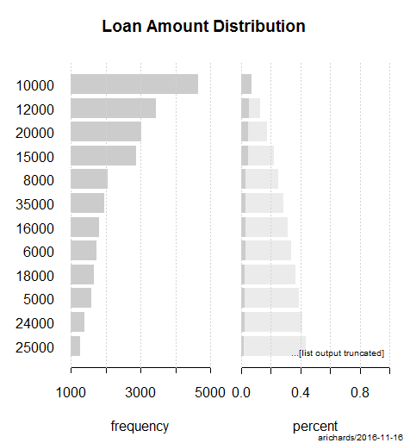

Most of the people had taken a loan of 10k.It was certainly very concerning to see such a high

population of people with so much in loans. One of the main reason was that people would rarely

borrow such an amount from bank as their application would be rejected .

Most of the people who got a loan had taken it had applied for a loan because they had

consolidated a high debt

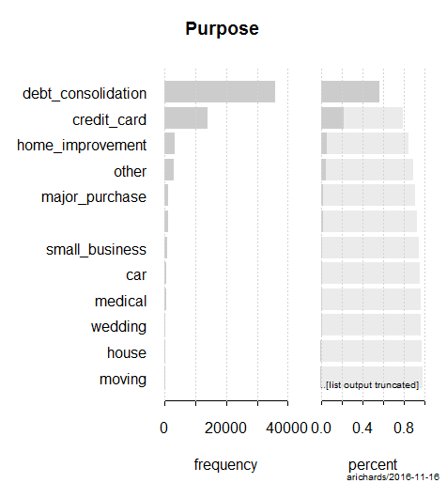

Most of the people had taken their loans because they had accumulated a enormous debt. In

addition to this around 20% of the people who went for a peer to peer lending had gone for

paying the credit card debt. Very less people went comparatively for their own personal interest

like car, house ,moving etc